Project management

  - FEASIBILITY STUDY:
    - Technical Feasibility:
This phase of the feasibility analysis deals with the computer-oriented feasibility of the system. As the name suggests, this phase tackles the technical problems of the system. The questions to be discussed are:

    - Operational Feasibility:
The operational feasibility is always a totally people-oriented approach. During this phase of feasibility analysis, the singular point-of-view is the people, the main users of the system. The problems that are likely to be faced by the users while operating on the system are thoroughly discussed during this phase. The main proposals are:
Performance
Performance of the system is good in terms of good throughput. All the users will get satisfactory information and get efficient output.
Information
All necessary information regarding the queries about the system would be available at correct time to the user in an efficient manner for e.g. user can visit the Frequently Asked Question page and can have answers at a moment.
Efficiency
All the resources available will be used up to good extent. They would almost 100% utilized and they would have been used in an appreciable manner. We also make reusable components and use it as required.
Control
There would an adequate control over the system. Enough security and authenticity mechanism would be provided, so that no one can go beyond their limits in terms of functionality performed at the site.
Economy
Some extra resources such as high capacity RAM, some software that are time effective to use such as ‘PHP’, xampp Server and various other resources have been used, but they all are economic and can be used by anyone in an efficient way without worrying about much from an economic view.
Service
This system provides user-friendly environment and very good functionalities that a lay man person can use it very easily.

  - PROJECT PLANNING:
2.2.1 Project Development Approach & Justification:

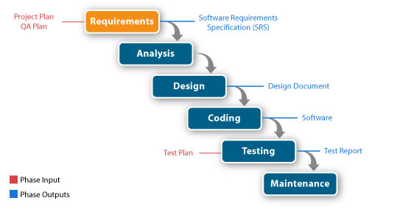
How use this model for developing this project
- First task of my project began with requirement analysis, in this task. We tried to understand what the need of user was. Then we are review our self about what we understood about project and prepared problem specification, which we showed to project manager and guide. And finally they approved problem specification and final specification.
- Then, we start to design this project prototype. We then designed a temporary data dictionary, which ultimately helped me to design various tables and helped me to build the relation among those tables. Then we constructed the data flow diagram.
- After successfully completion of design task we started coding for this project according to user’s requirement, our problem specification and our design.
- We went on in the same way as we did it in our application construction. The same techniques and methods were implemented to concrete the project. We started with our team members phase by phase module by module.
- Once the modules were made with their basic functionalities some other editing were done as under the guidance of the project head and guide. The changes were made keeping in mind the client’s requirements.
- Spellings, Grammar, Sentence formation, Message displays, all were checked again and formatted accordingly.
- Last but not the least the advanced page form layout was finalized, with each complete module. This made it ready to be unloaded any time as part of the Hotel Booking Engine with Connector. As and when the modules were ready the person configuring the website uploaded them.
- Looking through all these phases in our project we say that we have used Incremental model for software development.

  - PROJECT SCHEDULING:
The project schedule provides the road map for a software project manager. If it has been properly developed, the project schedule defines the task and the mile stones that must be tracked and also controlled as the project proceeds. Tracking can be accomplished in numerous ways:
- Conducting periodic project status meeting in which each team member reports progress and shares problems.
- Evaluating the results of all reviews conducted throughout the software engineering process.
- Determining whether formal project milestone have been accomplished by the schedule date.
- Comparing actual start date for each project task listed in the resource table.
- Meeting informally with practitioners to obtain their subjective assessment of progress to date and problem on the horizon.
- Using earned value analysis to assess progress quantitatively.
Control is employed by a software project manager to administrator project resources, cope with problems, and direct project staff. But when, problem occurs, the project manager must exercise control to reconcile them as quickly as possible.

